**6. N-Gram Model for Text Generation (Bigram Model)**

**Aim:**  
To implement a basic bigram model for text generation.

**Algorithm:**

1. Import necessary NLTK libraries.
2. Tokenize the text into words.
3. Create a list of bigrams and a frequency distribution.
4. Generate a sentence using the bigram probabilities.

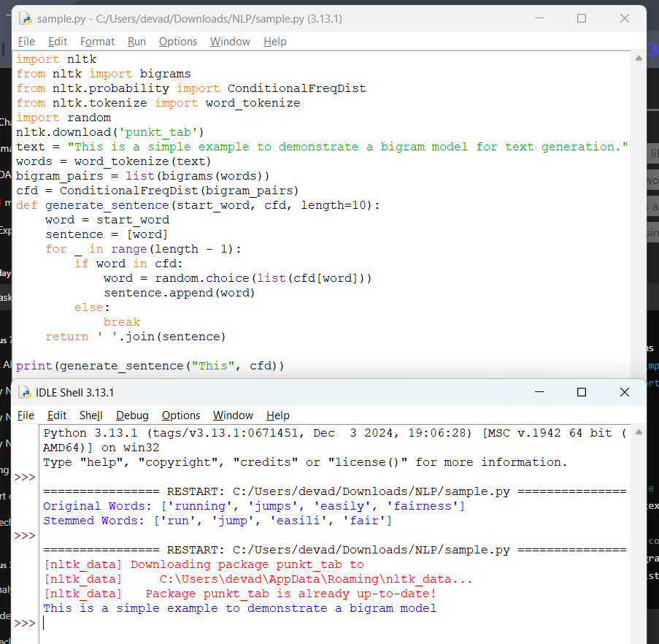

**Result:**  
The program successfully generates text based on bigram probabilities.